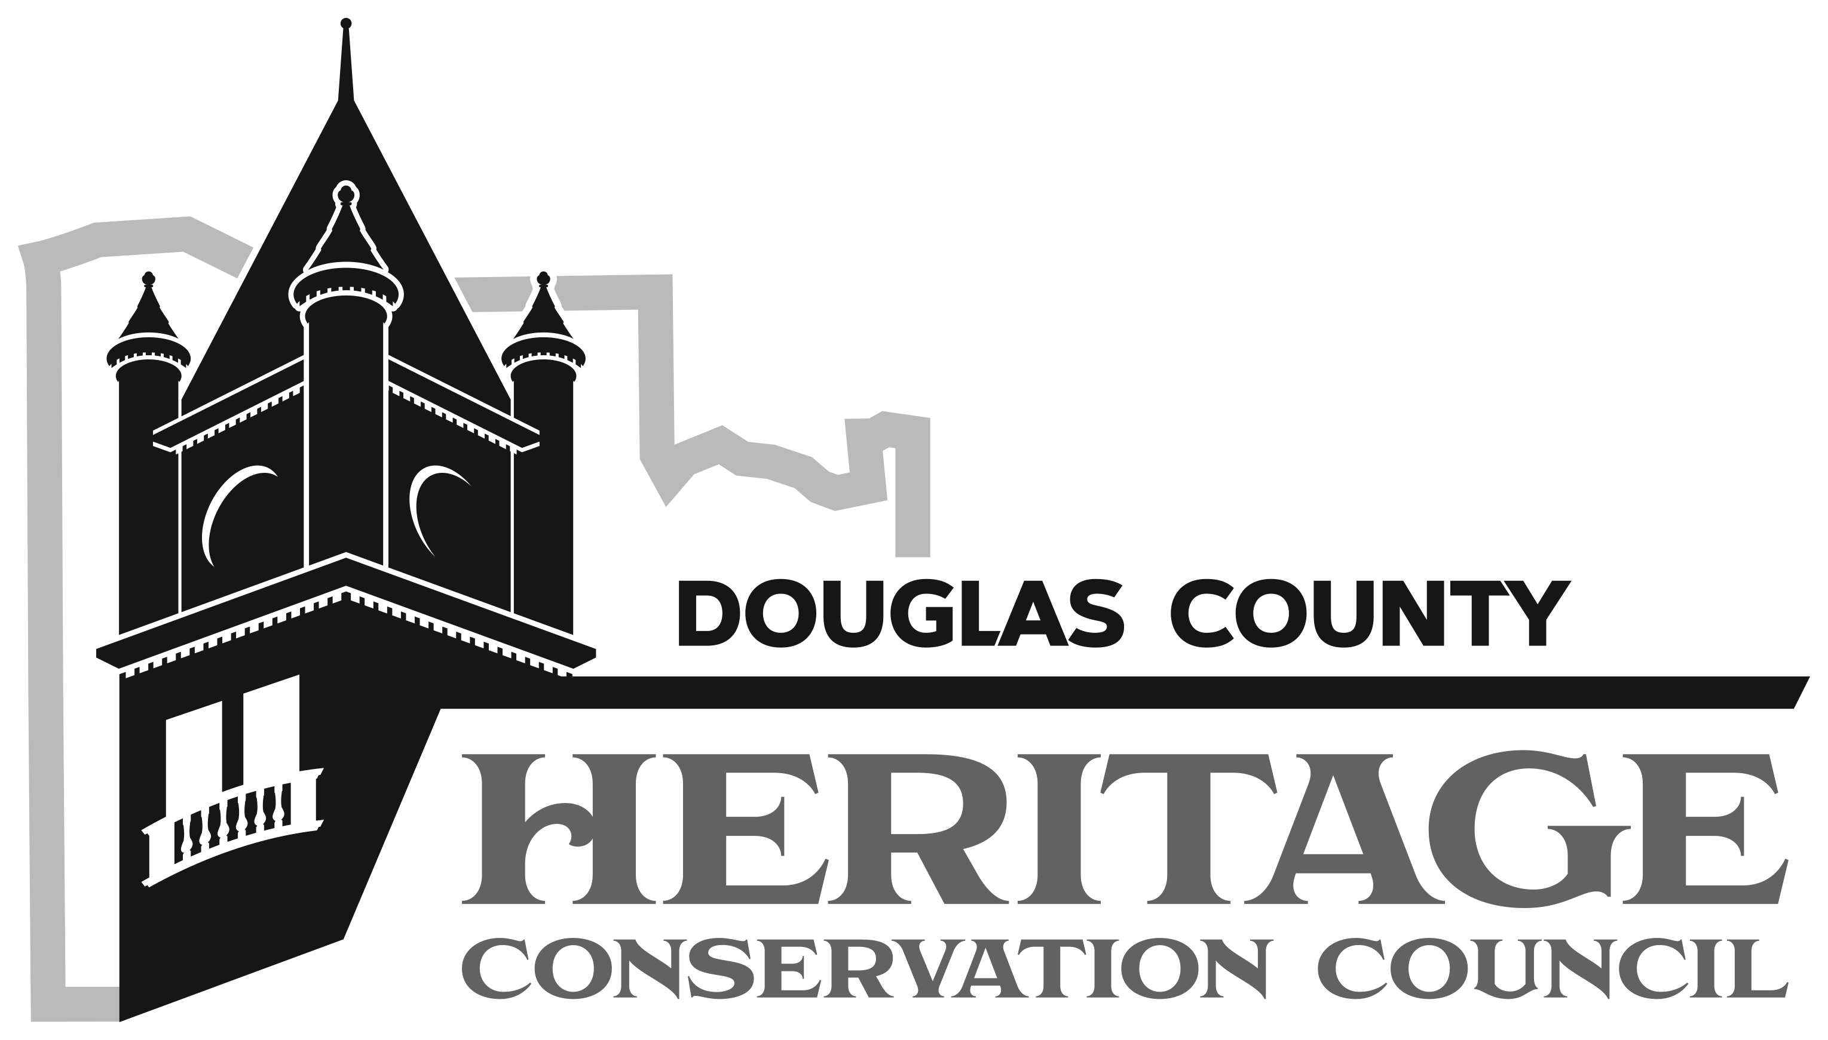
Douglas County Natural & Cultural Heritage Grant Program

Date:
Grant #:
Grantee:
Contact Person:
Telephone:
Email:

QUARTERLY REPORT INSTRUCTIONS

- All Grantees are expected to submit a Quarterly Report using this template. Please type responses to the questions and prompts below. Please be thorough and concise.
- Quarterly Reports should be submitted via email to the Heritage Coordinator by the end of the day on the third Thursday of each June, September, December, and March.
- Submit this completed form and all attachments as one PDF (14MB maximum) to kammerlaan@douglascountyks.org.
- Unless a signed amendment states otherwise, the Project Number, Grantee, Project Title, Authorized Official, and all other Project information should be the same as written in the signed Grant Agreement.
- If Grantees fail to submit reports, they may be ineligible to apply for subsequent grants from the Douglas County Natural and Cultural Grant Program.
- Include grantee name and grant number on all attachments.
- Relevant documents to include with this report may include:
- Building permits, zoning permits or other regulatory approvals
- Letter of determination from the State Historic Preservation Officer (SHPO)
- Changes in the make-up of the board of directors or other governing organization
- Tax credit applications.
- Any photographs documenting project work

Reminder: The Douglas County Heritage Conservation Council understands that unavoidable changes may occur during a project. If a change occurs in key project personnel (Authorizing Official, Project Director, grant-funded staff, or consultants), or a substantial change is contemplated in the project budget, scope, or schedule as described in the approved application, approval must be requested by the Authorizing Official as outlined in the performance agreement in a separate request to the Heritage Coordinator.

QUARTERLY REPORT

- Describe grant accomplishments that occurred during the quarter you are reporting on. If possible, describe activities or services in both quantitative and qualitative terms.

- How is your project publicly accessible? How is the project working to engage with and impact the Douglas County community?

- Is the grant project on-track with the goals established in the project application? If not, explain why and describe next steps.

- Do you anticipate that the project will be completed by the end date listed in the Grant Agreement?

- Does the grant project have upcoming learning or engagement opportunities that the public can interact with? If so, please share event details. How are you promoting these opportunities?

- Is the project team seeking other sources of funding for this work? Please explain.

- Do you have other comments or is there anything else you would like to share or highlight about the grant project? Include anecdotal information and/or lessons learned in this period.

- Please attach any relevant documents, photographs, outreach materials, or materials that show how the project has acknowledged the funds provided through the Douglas County Natural and Cultural Heritage Grant. Please provide photo credits and indicate if the County may share photos and outreach materials with the public.

  - ____Yes, Douglas County, Kansas may share the attached outreach materials and photographs and give credit to____________________.
  - ____No, Douglas County, Kansas may NOT share the attached outreach materials and photographs. Please explain.
  - ____Other. Please explain.

